**CHAROTAR UNIVERSITY OF SCIENCE & TECHNOLOGY**

Devang Patel Institute of Advance Technology & Research

Semester: III

Academic year: 2019-20

**ASSIGNMENT-1**

1. **List and explain in brief the components of a Data Communication System.**

The Basic Components of Data Communication System are as follows :

1. Message
2. Sender
3. Receiver
4. Medium/ communication channel
5. Protocol

**Message** is the data or information to be communicated. It may consist of text, number, pictures, sound, video or any a combination of these.

**Sender** is a device that sends message. The message can consist of text, numbers, pictures etc. it is also called source or transmitter. Normally, computer is used as sender in information communication systems.

**Receiver** is a device that receives message. It is also called sink. The receiver can be computer, printer or another computer related device. The receiver must be capable of accepting the message.

**Medium** is the physical path that connects sender and receiver. It is used to transmit data. The medium can be a copper wire, a fiber optic cable, microwaves etc. it is also called communication channel.

A **Protocol** is a set of rules and guidelines for communicating data. Rules are defined for each step and process during communication between two or more computers. Networks have to follow these rules to successfully transmit data

1. **What is topology ? List and explain in brief each topology.**

Network Topology is the schematic description of network arrangement, connecting various nodes i.e. senders or receivers through lines of connection.

1. **STAR TOPOLOGY –** All the computers are connected to a single hub through a cable. The Hub is the central node & all the other nodes are connected to the central node.

**Features**

* Every node has its own dedicated connection to the Hub.
* Can be used with twisted pair, optical fibre or co-axial cable.

**Advantages**

* Fast performance with nodes and low network traffic.
* Easy to troubleshoot
* Hub can be upgraded easily
* Easy to set up & modify

**Disadvantages**

* Cost of installation is high
* Expensive to use
* If hub fails whole network stops

1. **BUS TOPOLOGY –** Every network device is connected to single cable.

**Features**

* Transmit data in one direction
* Every device is connected to a single cable

**Advantages**

* Easy to expand
* Easy to understand
* Used in small networks
* Cost effective

**Disadvantages**

* Used in small networks
* Slower
* If Cables fail then whole network fails

1. **RING TOPOLOGY –** Forms a ring as each computer is connected to another computer with the last one connected to the first.

**Features**

* Data is transferred in a sequence manner i.e. bit by bit
* Repeaters are used to prevent data loss
* Transmission is unidirectional, but can be made bi-directional by having 2 connections between each network node

**Advantages**

* Cheap to install & expand
* Transmitting network is not affected by high traffic

**Disadvantages**

* Adding or deleting computers disturb the network activity
* Troubleshooting is difficult
* Failure of one computer disturbs the whole network.

1. **MESH TOPOLOGY –** It is a point to point connection to other node or devices. There are two techniques to transmit data i.e. Routing & Flooding

**Features**

* Fully Connected
* Robust
* Not Flexible

**Advantages**

* Each connection can carry its own data load
* Fault is diagnosed easily
* Provides Security & Privacy
* It is robust.

**Disadvantages**

* Installation and Configuration is difficult
* Cabling cost is more
* Bulk wiring is required

1. **HYBRID TOPOLOGY –** It is a mixture of two or more topologies.

**Features**

* Inherits advantage & disadvantages of topologies included

**Advantages**

* Reliable as error detecting is easy
* Troubleshooting is easy
* Effective
* Scalable as size can be increased easily
* Flexible

**Disadvantages**

* Complex in Design
* Costly

1. **Differentiate between TCP/IP and OSI Model.**

|  |  |
| --- | --- |
| **TCP/IP Model** | **OSI Model** |
| * Follows vertical approach * 4 Layers * Transmission Control / Internet Protocol * It is more reliable * It uses both session and presentation layer in the application layer itself * Transport Layer is Connection oriented * It is Client Server Model | * Follows horizontal approach * 7 Layers * Open system Interconnect * It is less reliable * It OSI uses different session and presentation layers * Both connection oriented & connection less * It is Conceptual Model |

1. **Explain in brief the function of each layer of the OSI Model.**

There are total 7 Layers in OSI Model:

**Layer 7**: The application layer. This is the layer at which communication partners are identified. This layer is notthe application itself, it is the set of services an application should be able to make use of directly, although some applications may perform application-layer functions.

**Layer 6**: The presentation layer. This layer is usually part of an operating system (OS) and converts incoming and outgoing data from one presentation format to another. For example, from clear text to encrypted text at one end and back to clear text at the other.

**Layer 5**: The session layer. This layer sets up, coordinates and terminates conversations. Its services include authentication and reconnection after an interruption. On the internet, Transmission Control Protocol (TCP) and User Datagram Protocol (UDP) provide these services for most applications.

**Layer 4**: The transport layer. This layer manages packetization of data, then the delivery of the packets, including checking for errors in the data once it arrives. On the internet, TCP and UDP provide these services for most applications as well.

**Layer 3**: The network layer. This layer handles addressing and routing the data, sending it in the right direction to the right destination on outgoing transmissions and receiving incoming transmissions at the packet level. IP is the network layer for the internet.

**Layer 2**: The data-link layer. This layer sets up links across the physical network, putting packets into network frames. This layer has two sub-layers: the logical link control layer and the media access control layer (MAC). MAC layer types include Ethernet and 802.11 wireless specifications.

**Layer 1**: The physical layer. This layer conveys the bit stream across the network either electrically, mechanically or through radio waves. The physical layer covers a variety of devices and mediums, among them cabling, connectors, receivers, transceivers and repeaters.

1. **Describe the various parameters of a Sine Wave.**

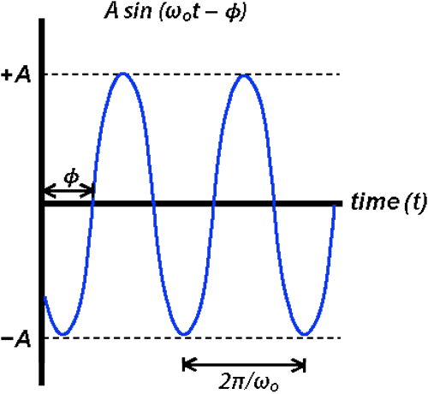

Various Parameters of Sine Wave are :

1. **FREQUENCY –** Number of complete cycle that happens every second. Frequency is generally measured in cycle per second.
2. **AMPLITUDE –** Maximum distance it reaches from 0. Since Sine Wave varies from -1 to +1 the Amplitude is 1.
3. **PHASE –** Angular shift between 2 or more Sine Wave. This angular Shift is generally as phase difference.
4. **How are digital signals transmitted? Give a brief about each method along with the diagram.**

Data is transferred in the form of bits between two or more digital devices. There are two methods used to transmit data between digital devices: serial transmission and parallel transmission. Serial data transmission sends data bits one after another over a single channel. Parallel data transmission sends multiple data bits at the same time over multiple channels

1. **Baseband Transmission –** Sending a digital signal over a channel we changing the digital signal to analog.

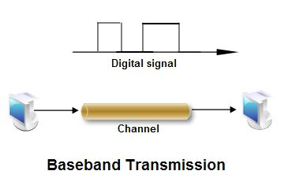

Baseband Transmission requires a low pass channel.

( Bandwidth that starts with 0)

1. 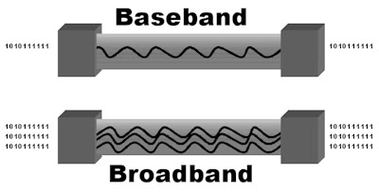**Broadband Transmission –** Sending a digital signal over a channel after changing the digital signal to analog signal ( i.e. requires modulation ) uses bandpass channel.

Bandwidth doesn’t starts with 0.

1. **List and explain the various Transmission Impairments.**

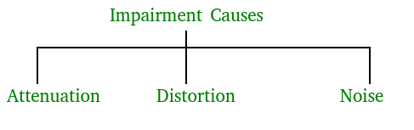

* **Attenuation –** It means loss of energy. The strength of signal decreases with increasing distance which causes loss of energy in overcoming resistance of medium. This is also known as attenuated signal. Amplifiers are used to amplify the attenuated signal which gives the original signal back.

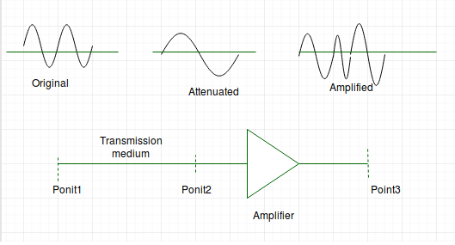

Attenuation is measured in **decibels(dB)**. It measures the relative strengths of two signals or one signal at two different point.

P1 is power at sending end and P2 is power at receiving end.

Attenuation(dB) = 10log10(P2/P1)

* **Distortion –** It means change in the shape of signal. This is generally seen in composite signals with different frequencies. Each frequency component has its own propagation speed travelling through a medium. Every component arrive at different time which leads to delay distortion. Therefore, they have different phases at receiver end from what they had at senders end.
* **Noise –** The random or unwanted signal that mixes up with the original signal is called noise. There are several types of noise such as induced noise, crosstalk noise, thermal noise and impulse noise which may corrupt the signal.

1. **Write the equations for Noiseless and Noisy Channels.**

Equation for NOISELESS CHANNLE

For a noiseless channel the Nyquist bit rate formula defines the theoretical maximum bit rate.

**BITRATE** = 2 * Bandwidth * Log2(L)

*Here L = Number of Signal Levels*

*Bitrate in bps*

*Bandwidth in Hz*

The data rate is directly proportional to the number of signal levels as the bandwidth of the signal is fixed.

Equation for NOISY CHANNEL

For a noisy channel the Shannon Capacity defines the highest data rate,

**SHANNON CAPAACITY** = Bandwidth * Log2(1+SNR)

*Shannon Capacity in bps*

*Bandwidth in Hz*

In this case Shannon Capacity is directional proportional to Signal-to-Noise ration (SNR) or bandwidth is fixed.

1. **What is Signal-to-Noise Ratio?**

Signal-to-Noise Ratio (usually abbreviates as SNR ) is the ration of Signal Elements to Noise which compares the level of desired signal to the level of background noise. SNR is defined as the ratio of Signal Power to Noise Power.

SNR = POWER SIGNAL / POWER NOISE

It is generally expressed in Decibels (dB).

The ratio greater than 1 : 1 indicates that signal is more powerful than noise which indicates the better quality.

**10. Solve the following:**

a. Calculate the maximum bit rate of a noiseless channel with a bandwidth of 2000Hz transmitting a signal with two signal levels.

b. Assume that SNRdB = 30 and the channel bandwidth is 3 MHz. Calculate the capacity of the channel.

c. The bandwidth of a channel is 4 MHz. The SNR for this channel is 51. Calculate the bit rate and signal level.

**Solution :**